***Level-6 Final Assessment***

***LimeLight Theatre***

***Booking System***

Project Proposal………………………………………………………………………………..2

Goals and Objective……………………………………………………………………………2

Project Description……………………………………………………………………………..3

Database Design……………………………………………………………………………….3

Project Specification……………………………………………………………………………4

Resource Requirement………………………………………………………………………….4

***Objective and Goals***

*The objective of the booking system is to provide a system so that audience members can book tickets for the theatre. Admins must therefore have the ability to enter the needed information into the database so that users can choose from it. The idea is for it to be attached to the current website and therefore use the style of it but I have included a basic style that somewhat approximates this.*

***Project Description***

*The project design is quite simple. It allows users to book tickets for upcoming shows that are coming up with Lime Light Theatre. Before the user can put in any information however, the upcoming shows must be placed in the database by a registered administrator. Luckily there is only one kind of user as audience members have no need to register so I did not have to separate by different kinds of login. The login page is hidden from the user and is found by clicking on the Repertory logo. Upon acceptance of a valid login the administrator now has the ability to add and edit shows, as well as removing any entered in error or are no longer applicable. After entering the* *shows they then have the ability to add, edit or remove show times. Each show falls on multiple dates. After this audience members are free to book seats. Generally this works the same way as picking performances for the admin, but the users do not have the ability to edit or delete anything.*

*It is simply a straight trip through.*

***Database Design***

*For the database I chose to have four tables. The first is shows, which is simply the name of the show, and is simple enough as the theatre only has one show on at once. The second is performances. This is the date that the shows are on. For example a production of Chichago might be on for ten nights so there would be ten productions to a show. For there the audience makes a booking, in the booking table, putting in their name and how many tickets they want, this will also put in a price, with the hopes that this would be sent through to an online payment system. After that they are sent to seats to choose their seats, which lets them pick as many seats as they have chosen in the booking.*

## ***Project Specifications***

* *Login and registration of Audience by admin*
* *Add, update and delete of Audience registration by the admin*
* *Admin can add, edit, and update Booking for Audience.*
* *Audience can only view their details in the system. They cannot register, They can edit and Delete the details only.*

## ***Resource Requirements***

* *64-bit processor and 8 GB or more RAM*
* *Windows Operating System*
* *Asp.net MVC Framework*

*Identity framework- ASP*

## ***Design***

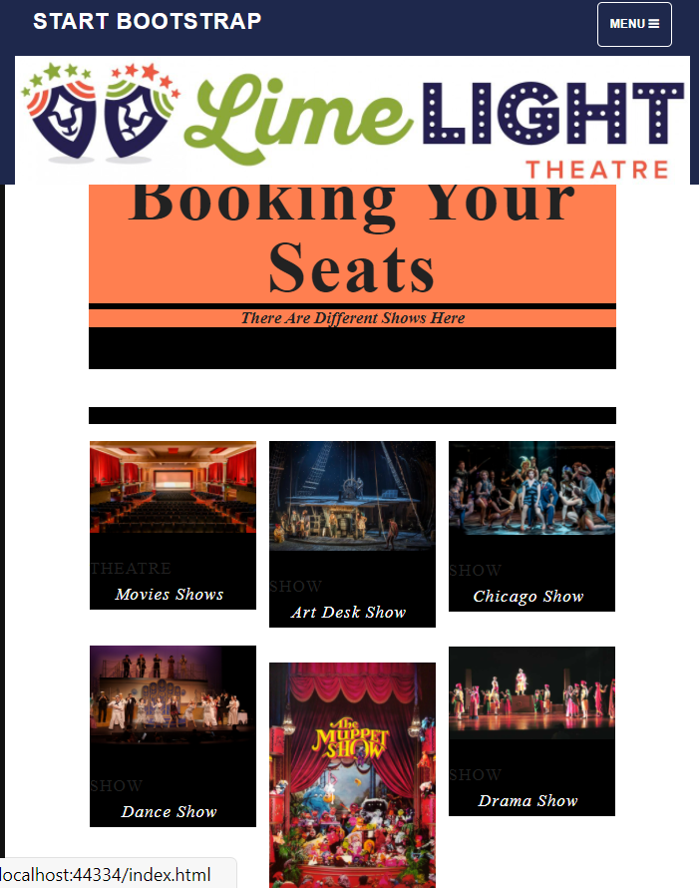

### ***Home Page***

*This is the main home page of the application. On this page there are Five buttons on the navigation page- Home, Shows, Performances, Bookings, Seats register, login.*

### ***Register Page***

### 

### *In this page admin can register a customer. User needs to enter a valid email and password and need to confirm password and need to click on register*

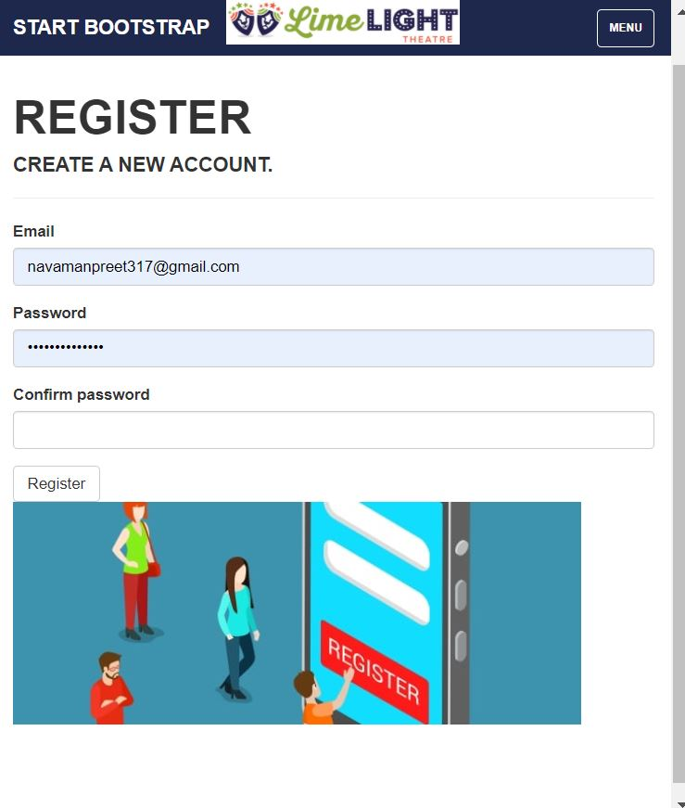

### ***Login Page***

*Once admin registers a customer successfully with the Customer Booking application, he/she can log in to the application as a registered user and view the details.*

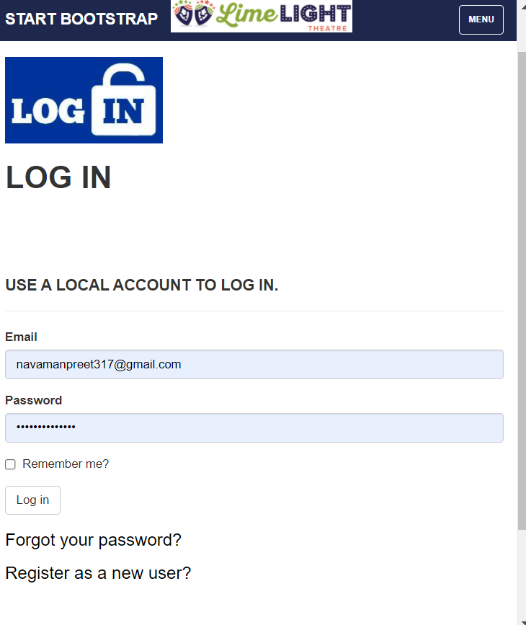

***Show Page***

*In this Show page I have four buttons edit, delete, details, create New with the help of these buttons you can easily add, edit, delete, and view details of any show.*

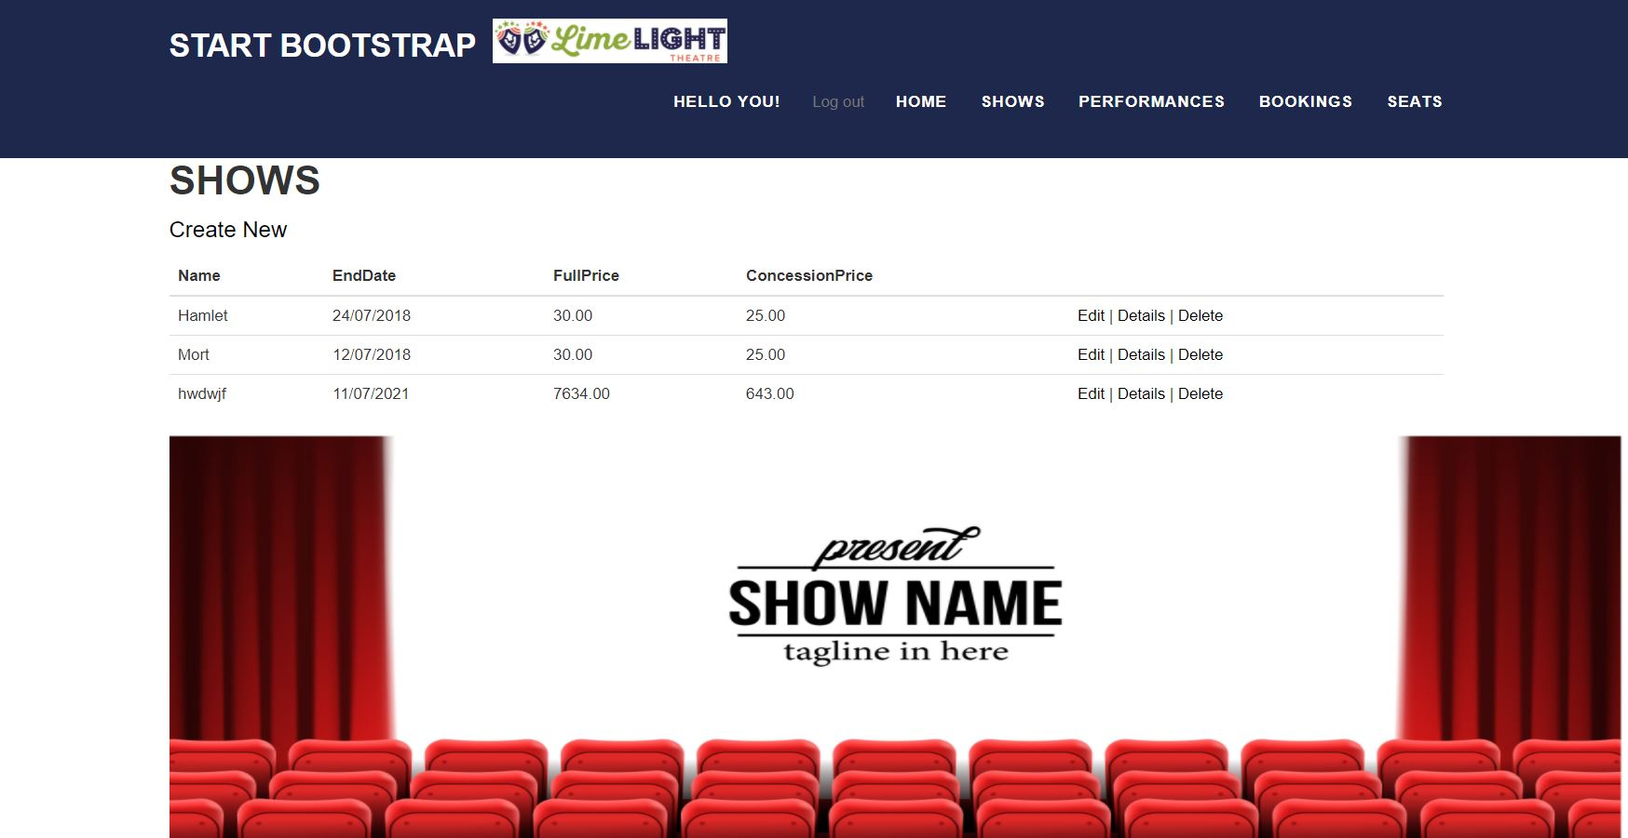

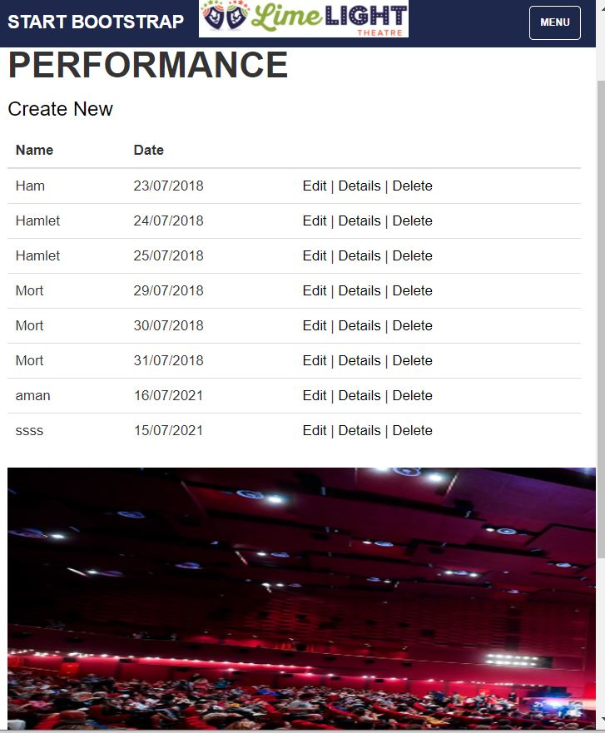

***Performance Page***

*With the help of this page I have four buttons edit, delete, details, create New with the help of these buttons you can easily add, edit, delete the performance and view details of any Performance.*

***Booking Page***

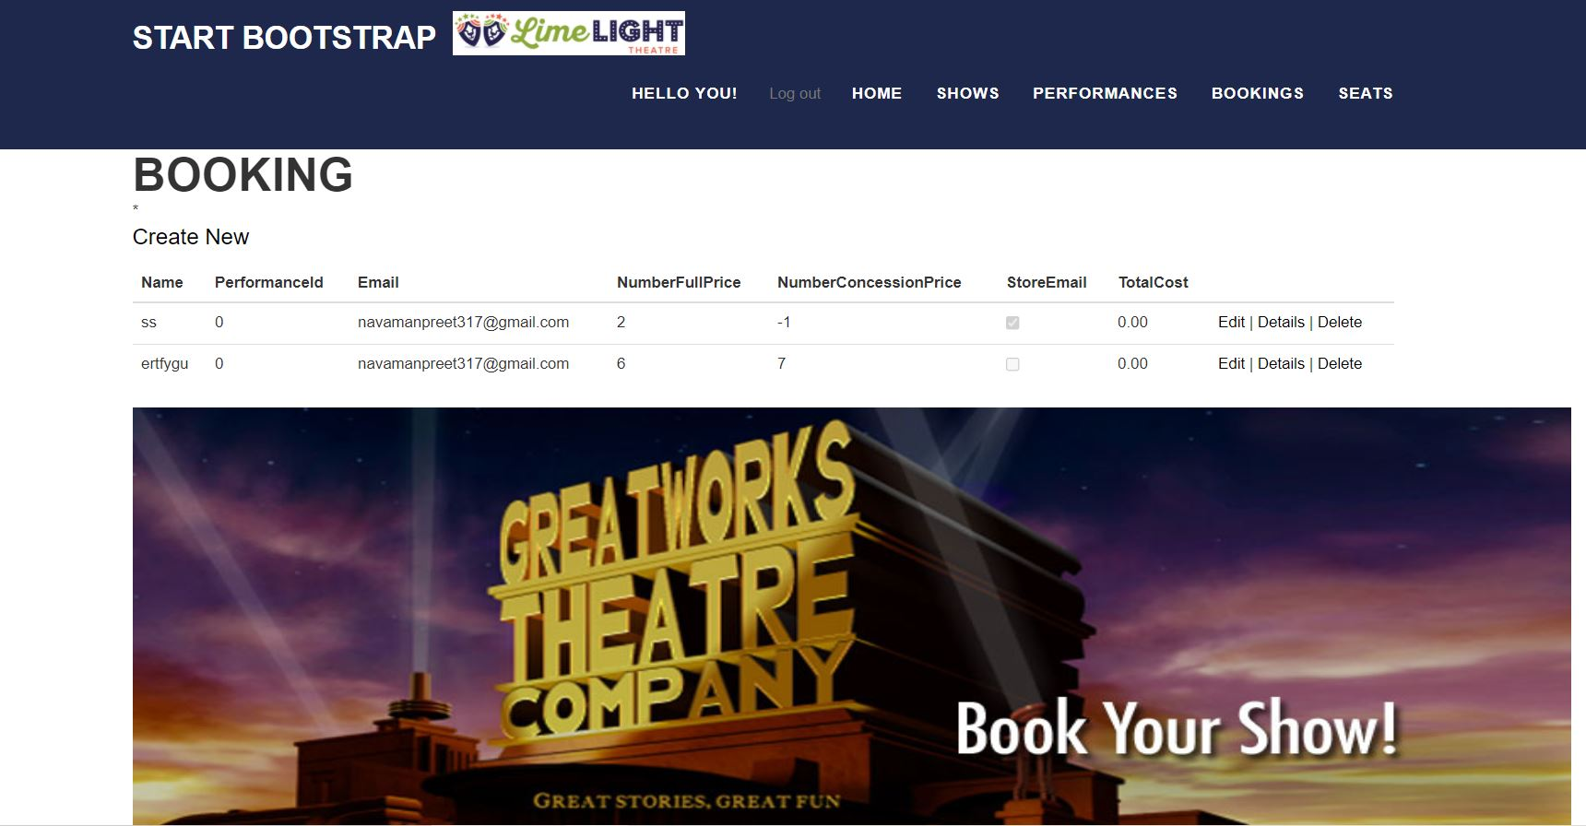

*In this Booking page I have four buttons edit, delete, details, create New with the help of these buttons you can easily add, edit, delete, the booking and as well as you can view details of booking.*

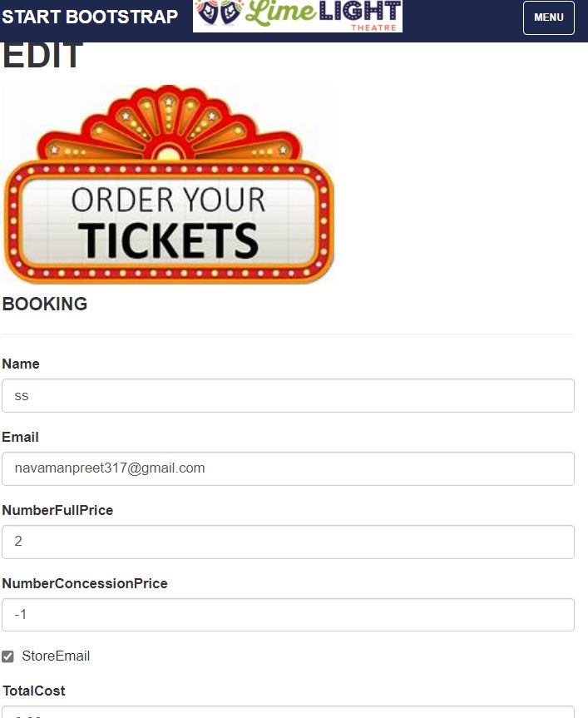

***Booking edit page***

*You can change your booking details in this edit form.*

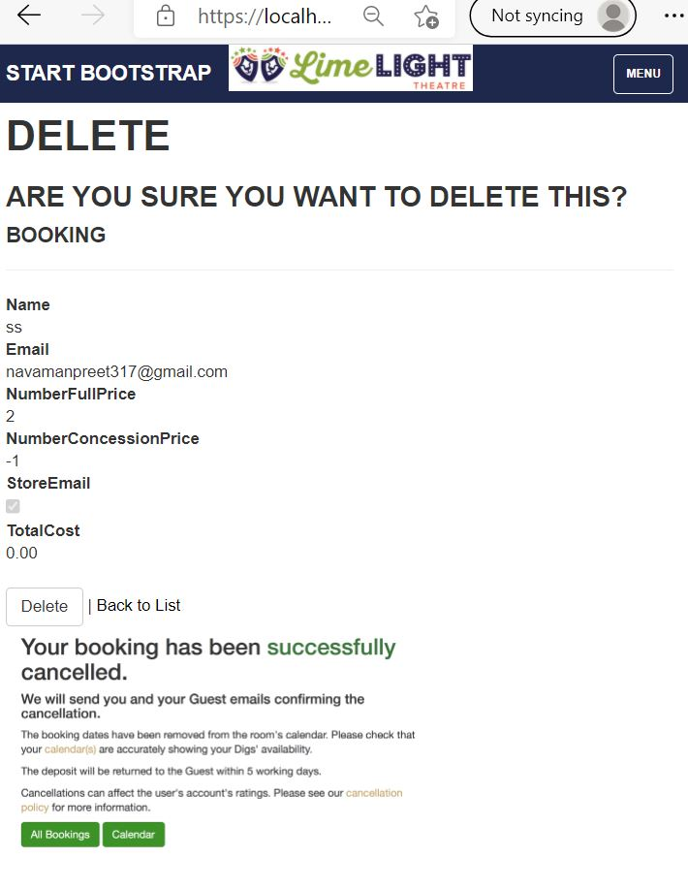

***Booking Delete Page***

*You can delete your booking easily with the hep of this form.*

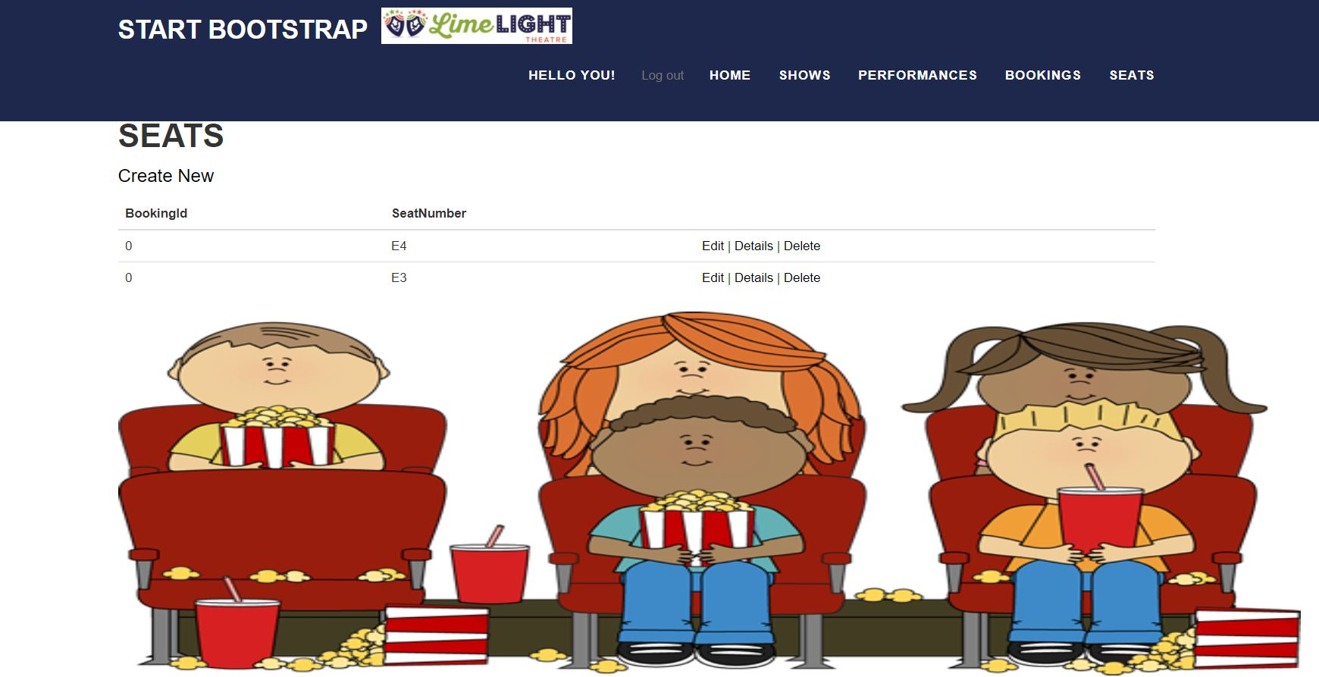

***Seats Page***

*In this Seats page I have four buttons edit, delete, details, create New with the help of these buttons you can easily add, edit, delete, the seat booking and as well as you can view details of seat booking.*

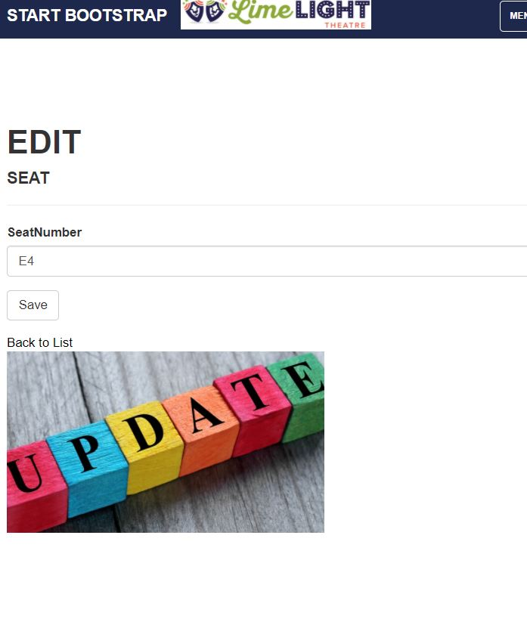

***Seats Edit Page***

*With the help of this page you can change your seat Number*

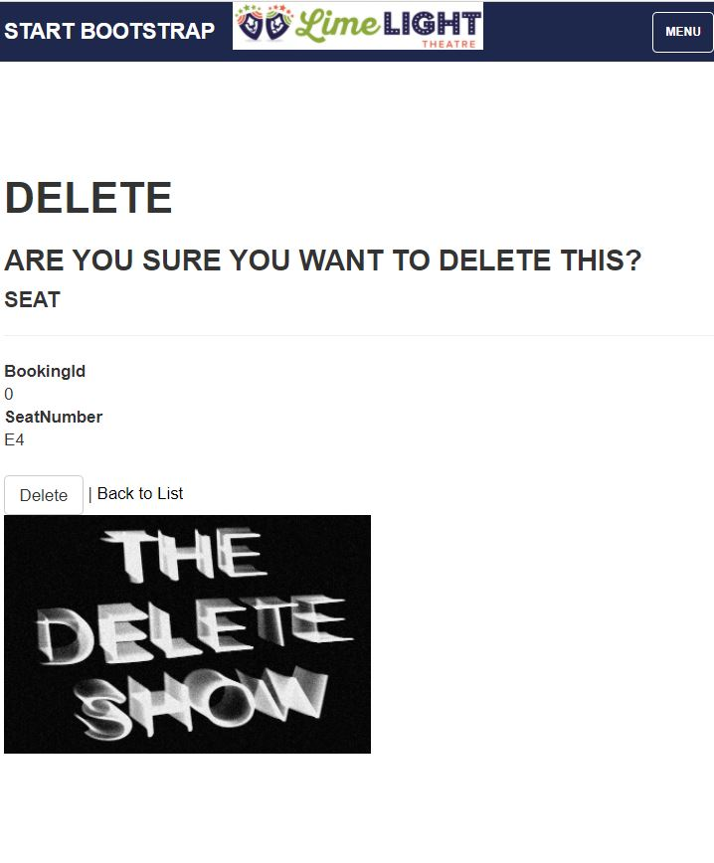

***Seats Delete Page***

*In this page you can cancel your seat and add new one.*

# *User Manual*

## ***Quick Setup Guide***

### *User Setup*

#### As a web application there is no need for a separate configuration for the intended Audience, but registrations are available through the website to access its functionality. The web application can be accessed through local hosting.

### Admin Setup

#### Admin needs to login using valid Information.

#### Admin is responsible for managing Audience, Booking, Shows and Performance.

## ***System Summary***

Booking System is a web application developed using Asp.net MVC Framework. It operates on most modern web browsers and requires no special program configuration. As a web application, internet access is needed.